Cosmetic Interest Questionnaire
NAME: ______________________________ DATE OF BIRTH: ____________________ DATE: _______________
Check which areas of the face concern you on the diagram below.
By showing how you see yourself, we can best evaluate your aesthetic goals and select an appropriate treatment for you.
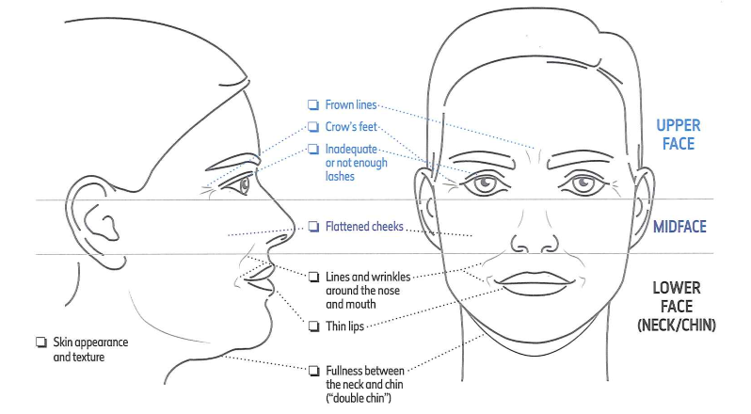
Please indicate if you are interested or would like to learn more about any of the following services below:
(Check all that apply)
- Botox injections | - Dermal Fillers
- Fat Reduction | - Chemical Peels
- Laser Hair Reduction | - Treatment of wrinkles
- Brown spot/Age spot removal | - Acne scarring
- Skin Care Products | - Facial redness/rosacea treatments
- Other (Please Specify):
Please provide your email address to join our list to receive exclusive information about Special Offers, Brilliant Distinctions, and Events.
Current email address: ____________________________________________________
** Payment in full is required prior to all cosmetic services being rendered. _________
(Provider will review cost of cosmetic services prior to treatment.)
For Office Use Only:
Recommended Cosmetic Procedures
Fillers | Chemical Peels | Laser Hair Reduction
- Silk | - Illuminize | - Upper Lip | - Legs (half/full)
- Restylane | - Vitalize | - Chin | - Bikini
- Perlane | - Rejuvenize | - Ears | - Brazilian
- Juvederm Ultra |  | - Neck | - Forearms
- Juvederm Ultra Plus |  | - Underarms | - Full Arms
- Voluma |  | - Navel
- Volbella |  | - Upper chest
- Vollure |  | - Head
 |  | - Back (half/full)
- Botox | - Kybella
Recommended Skin Care Products
SkinMedica | EltaMD
- HA5 | - Intense Moisturizer
- Retinol 0.25% | - UV Shield Broad Spectrum 45
- Retinol 0.5%
- Lytera 2.0
- TNS Essential Serum
- Essential Defense Mineral Shield Sunscreen SPF 35
- Total Defense & Repair Sunscreen SPF 34 (Tinted)
- Total Devense & Repair Sunscreen SPF 50 (Untinted)

Brilliant Distinctions member email:________________________________________________

Notes

Provider Signature: __________________________________________________________ Date: _________________

